Dear Member,
Selection of the Conservative Party candidate for the 2020 election for Police & Crime Commissioner – Saturday, 29th February 2020

Since the election of Flick Drummond to Parliament a vacancy has opened for the Conservative candidate for the PCC elections on 7 May 2020.

A Special General Meeting of members residing in Hampshire and the Isle of Wight will be held on Saturday, 29th February 2020 at the Meonstoke Hall, Pound Lane, Meonstoke SO32 3NP starting at 2.15pm.

An independent moderator will question each candidate for 15 minutes of pre-registered questions. This will be followed by 10 minutes of Q & A from the floor. Please submit your question to dirk.russell@conservatives.com.

I hope you will be able to attend and take part in this important exercise - selecting Conservative candidates is an important privilege of party members.
PRE-REGISTRATION:
In order to attend you are encouraged to pre-register using the following web address: https://tinyurl.com/vyt86y2
Alternatively, you can email dirk.russell@conservatives.com to register.
You have to be a paid-up member of the Party, living in Hampshire and the Isle of Wight, and have been a member on or before the 29th November 2019.

I look forward to seeing you on the 29th February.
Yours sincerely,
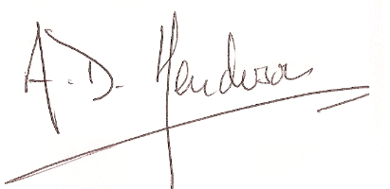
Andrew Henderson
Hampshire and the IoW Area Chairman

